Spare parts for system ANDREW (ANDREW COMMSCOPE) ION-B /
ЗЧ для системы ANDREW (ANDREW COMMSCOPE) ION-B
1 pc of Subrack ION-B TPRN64 (complete with DC, power supply in set / с DC, блоком питания в комплекте) 12 slots / 12 слотов
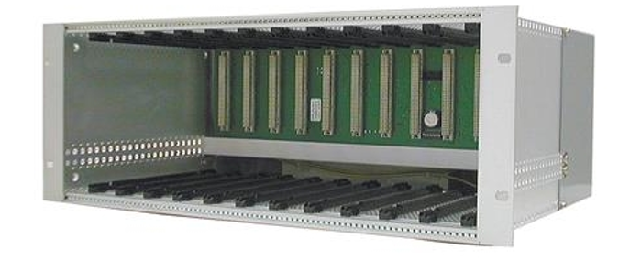

TPRN64TPRN64
ION®-B Series Subrack, dc
General Specifications
Brand ION®
Note Detailed Product Specifications are available. Please contact your local CommScope
representative.
Electrical Specifications
Voltage Range +12 to +13 Vdc
Regulatory Compliance/Certifications
Agency Classification

